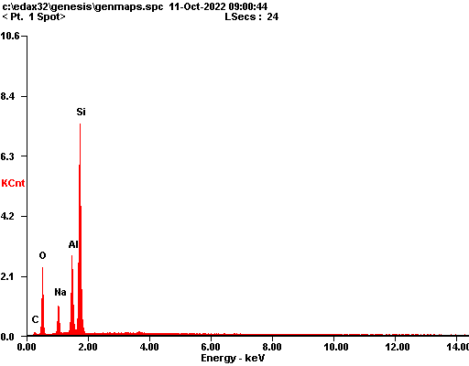

|  |  |  |
| --- | --- | --- |
| ***Element*** | ***Wt%*** | ***At%*** |
| ***CK*** | 06.14 | 10.50 |
| ***OK*** | 34.70 | 44.53 |
| ***NaK*** | 08.31 | 07.43 |
| ***AlK*** | 12.63 | 09.61 |
| ***SiK*** | 38.22 | 27.94 |
| ***Matrix*** | Correction | ZAF |

